**18AIS201T- Linear Systems and Signal Processing**

**Unit-1 Assignment-1**

1. Write the mathematical representation and draw the graphical representation and of the following signals (4 Marks)

Unit Impulse

Step,

Ramp,

Pulse.

1. Find whether the following signals are periodic or not (8 Marks)

(i) x(n)=ej8π ( n+π/6)

(ii) x(n)=sin2πn+ sin6πn

(iii) x(t)= u(t)+2cost

(iv) x(t)=3 cos(11πt-π/3)+2sin(13πt- π/3)

1. Compute the signal power and signal energy for the given signal (8 Marks)

$$x\left(n\right)=e^{j10n}u(n)$$

x(t) = 2cost

1. Find even and odd components of the following signals (4 Marks)

$$x\left(t\right)=sin t+2sinsin t +2\sin^{2}t cos t$$

$x\left(n\right)= \left\{1, 0,-1, 2, 3\right\}$

1. Plot the value of following:(10 Marks)
2. 2 $x(t-3)$ 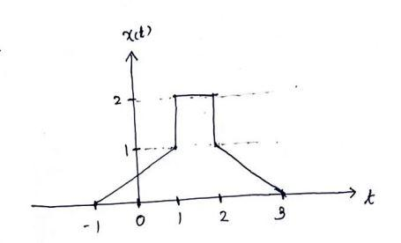
3. x($\frac{3}{2}t)$
4. x($\frac{3}{2}t-2)$
5. x(-t+2)
6. x(2t+4)
7. Plot the following:(6 Marks)

(a) y(n)= 2u(-n+3)

(b) x(t)=r(t). u(2-t)